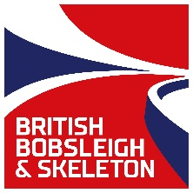
GB Bobsleigh - Talent Transfer
Application Form
Please note that completing the below does not guarantee you a place at either of the squad trials. All applications are assessed on a case by case basis and successful applicants will be invited to attend one of the trial dates listed below.
Trial Dates: Saturday 9th July & Saturday 6th August 2016
Trial 1 Venue: Alexander Stadium High Performance Centre, Walsall Road, Perry Bar, B42 2LR
Trial 2 Venue: Lee Valley Athletics Centre, 61 Meridian Way, Edmonton, London N9 0AR
Preferred Trial Date:
Full Name:
D.O.B & Age:
Home Town:
Occupation:
Contact Email:
Contact Number:
Height (cm):
Weight (kg):
Sporting Background:

Highest Level of Competition:

Training Age (how many years have you engaged in competition-based training?):
Do you have any injuries that would prevent you from completing a trial?
Briefly outline how you meet one or more of the desired/ minimum standards.
If not, is there a standard we haven’t outlined that you would identify as being transferable?

Please complete fully and return to rob.condliffe@thebbsa.co.uk Successful applicants will be notified and sent a timetable for the day no later than one week prior to each trial.

