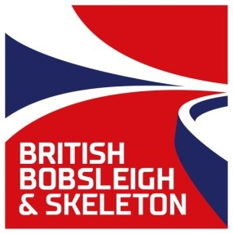

BRITISH BOBSLEIGH & SKELETON CHAMPIONSHIPS 2016-17
ENTRY FORM

IGLS, 25th & 26th November 2016

1) The deadline for ALL entries is at midnight on Monday 14th November 2016.

2) The names of the Brakeman / Brakewomen and 4-Man Crew may be nominated after submitting the entry form, but must be provided, together with emergency details and insurance details at the first Team Captains Meeting (TCM) on Sunday 20th November 2016.

3) Entry forms are to be submitted by E-mail to lucy@hannell.co.uk or by post to: British Championships, British Bobsleigh and Skeleton Association, 5 South, University of Bath, Claverton Down, Bath BA2 7AY with the entry fee. (Cheques to be made payable to “BBSA”.)

4) Entry fees must be paid in full before the first TCM on Sunday 20th November 2016.

5) Training Fees are to be paid in full by cash in Euros at the Race Draw.

Name of Team Captain
Contact phone number
Name & Address of accommodation of Team Captain for the Championships
Proposed Date for commencement of running (to help with track administration)
Team Entry Fee (includes two race runs)
Skeleton - £60
Bobsleigh - £100
Youth Entry (aged between 15 & 17)
Veteran Entry (driver aged 45 or over, with a combined age of at least 80 years (Bobsleigh))
Name of Driver
Contact name in case of emergency
Contact phone number in case of emergency
Insurance company name
Insurance policy number
Name of Brakeman (Bobsleigh only)
Contact name in case of emergency
Contact phone number in case of emergency
Insurance company name
Insurance policy number
Name of Crewman (4-man Bobsleigh only)
Contact name in case of emergency
Contact phone number in case of emergency
Insurance company name
Insurance policy number
Name of Crewman (4-man Bobsleigh only)
Contact name in case of emergency
Contact phone number in case of emergency
Insurance company name
Insurance policy number

Bobsleigh and Skeleton are dangerous sports and, whilst the organisers shall take all practicable precautions to ensure safety, competitors participate at their own risk.

